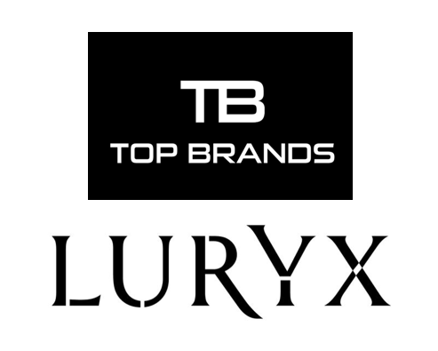

ASUTIL – ARTICLE
JUNE 2018

Panama-based Top Brands International is undergoing a double name change – both on the corporate side and for the stores it operates to give the company a new image and a new look moving forward.
In the last two years, we have been growing rapidly. We are expanding so much that we needed something to reflect that expansion and growth.
We dropped the international, so we look and sound more corporate. This also helps to encompass all the different business units we have.
Now, we are much more of a corporation than a small operation in the region. And that is the reason why, when looking at our future expansions we decided to go with a more corporate name and identity.
LURYX is modern, elegant and luxury name for our Stores where we will transform the consumer shopping experience. “They will be innovative and modern duty-free stores where you will find a wide variety of products of prestigious and recognized brands.”
The development of the LURYX name is a result of the success that the company has been having throughout the region in recent years.

Joanna Gutierrez
Marketing Manager
Top Brands International

